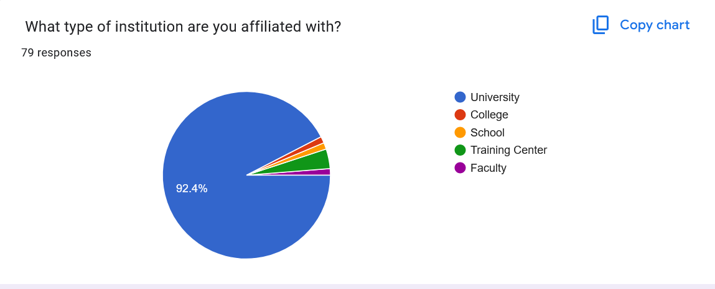 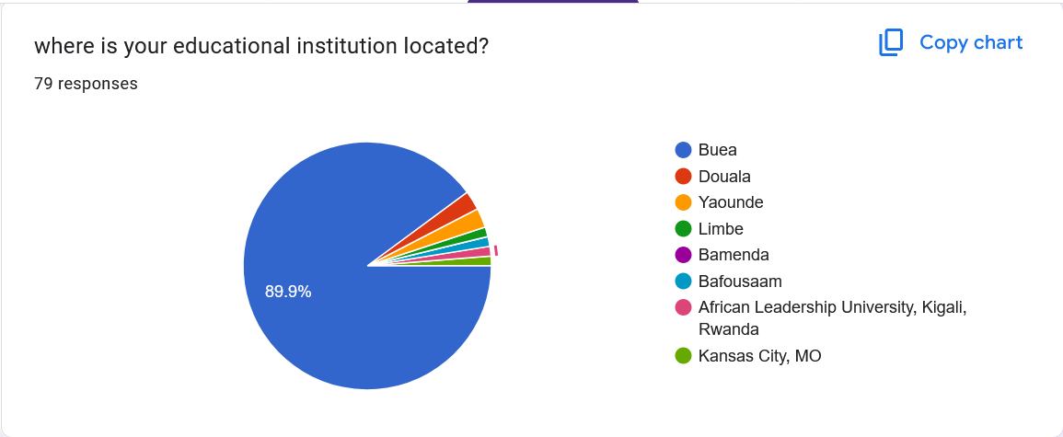

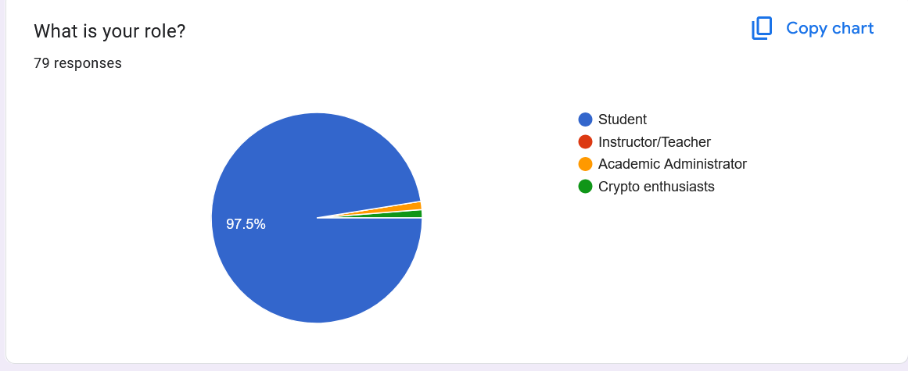

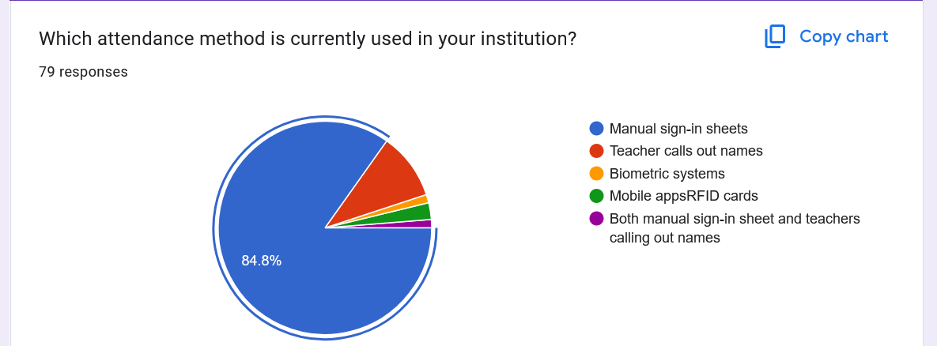 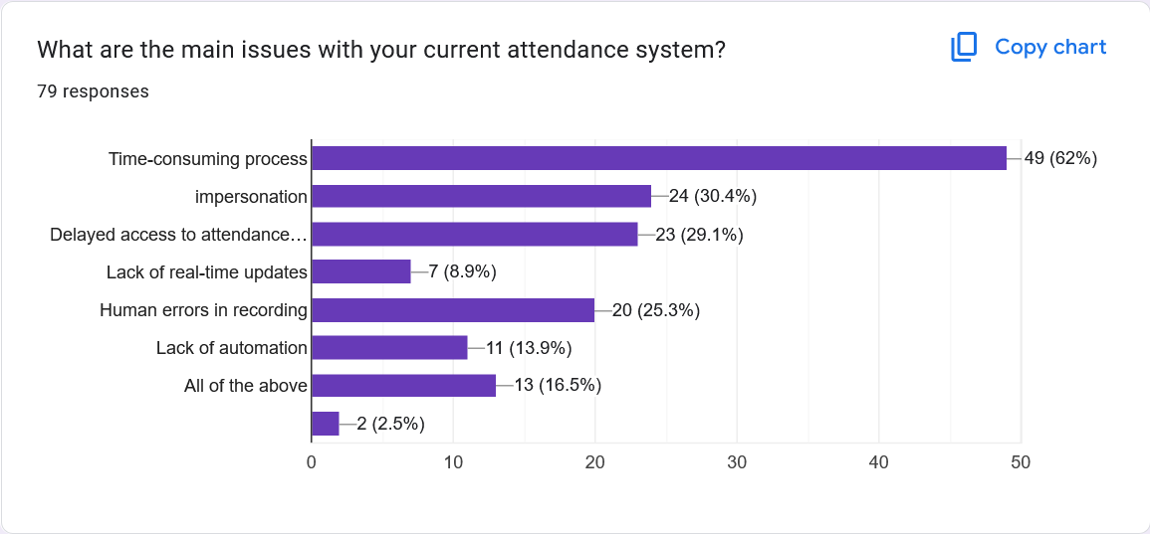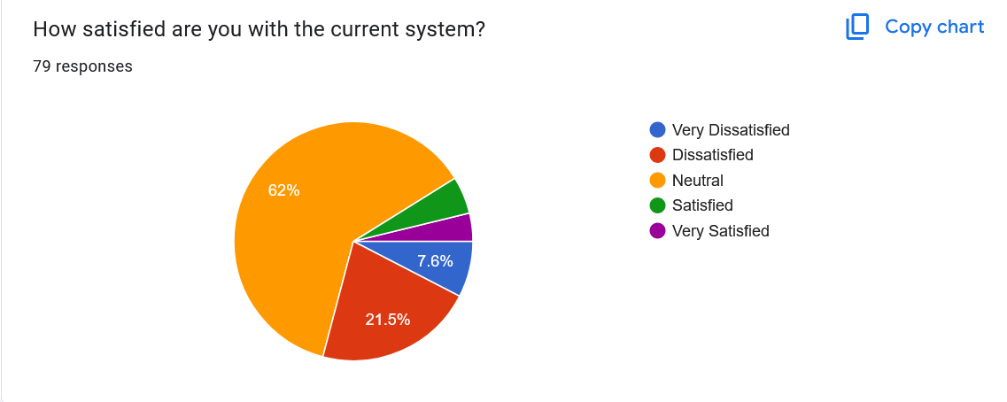

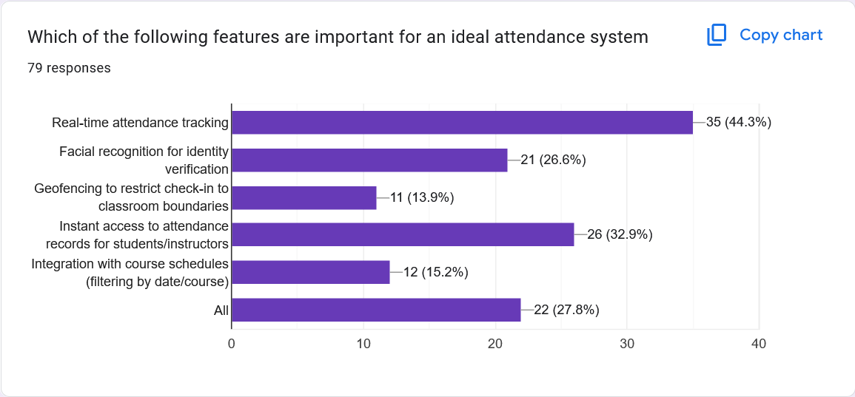

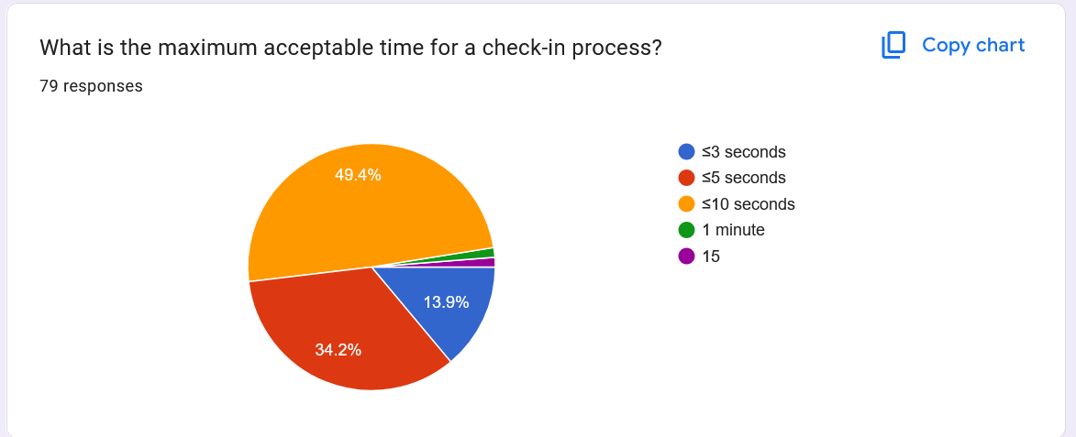 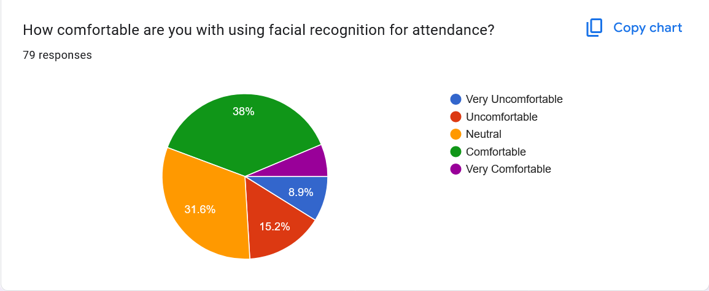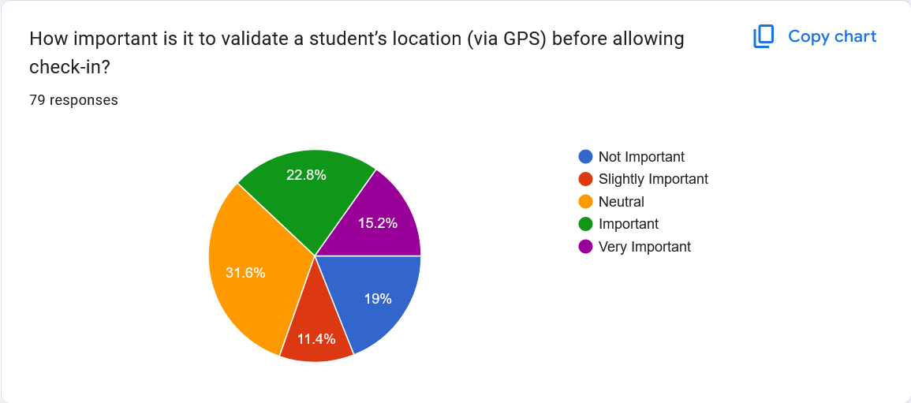

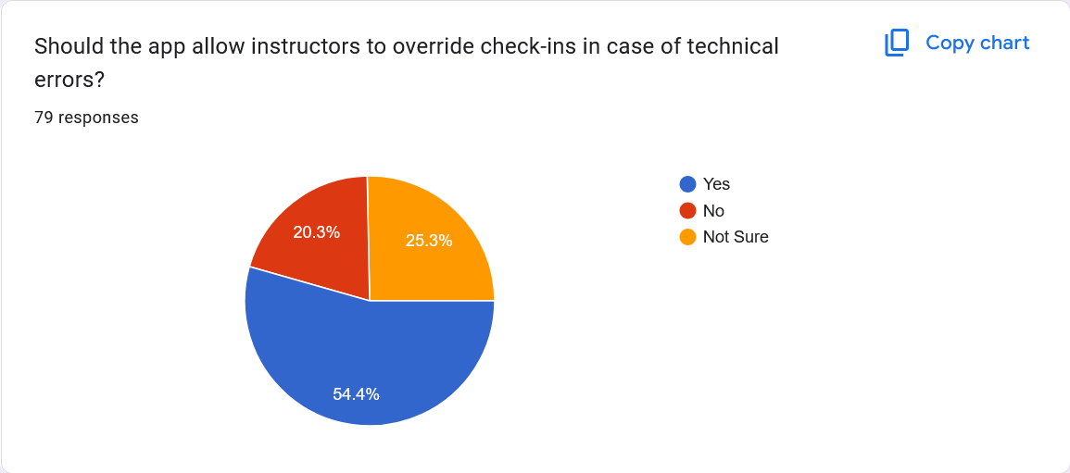

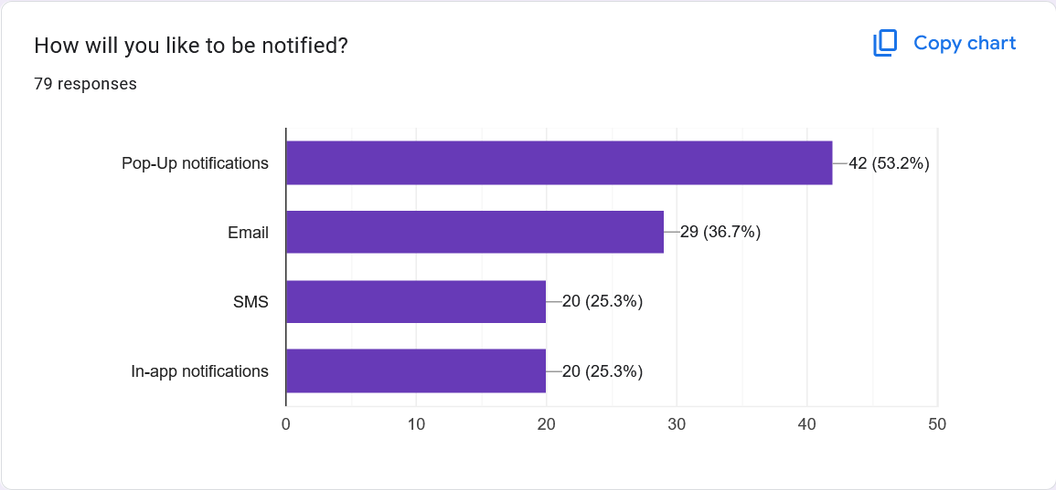

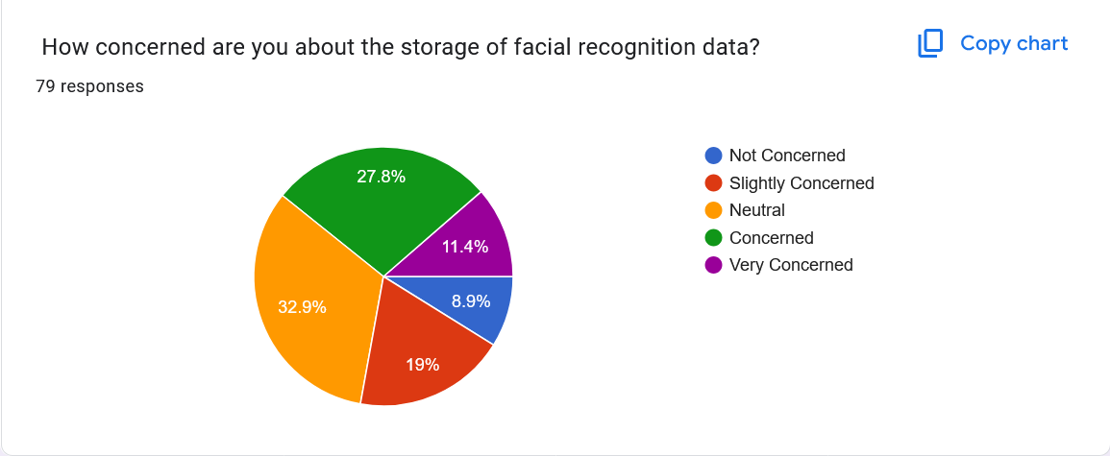 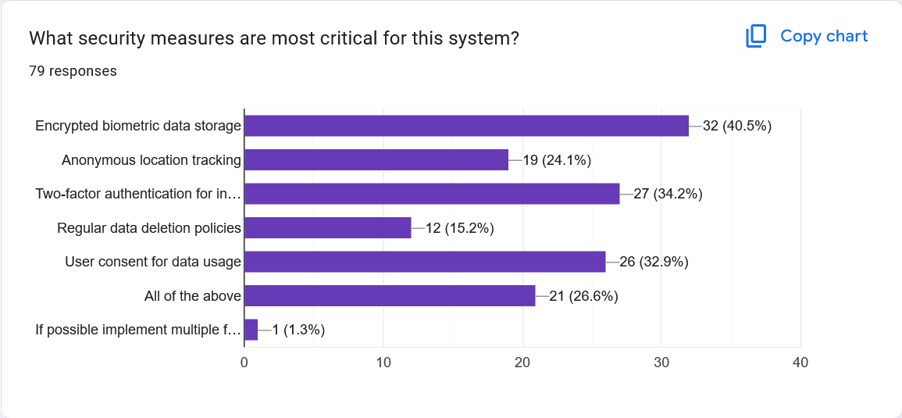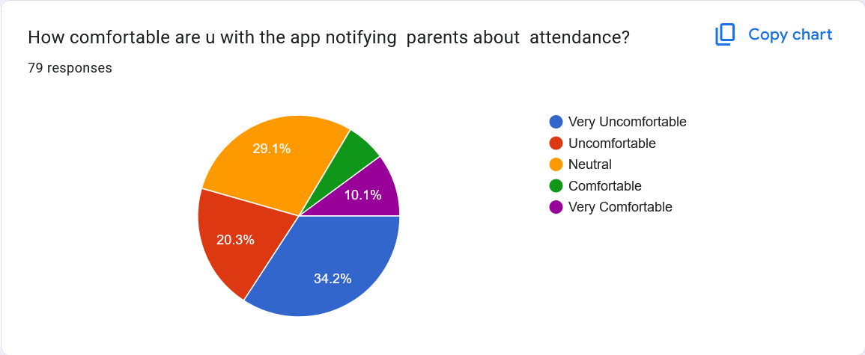

Do you have any suggestions, comments, or concerns about the proposed system?   
37 responses

1. No
2. Nope
3. Nope
4. This is a very good innovation. I anticipate to see the realization of this project.
5. I'll think about it and tell you later
6. The current school system isn't on pair with such a system
7. The system is a good idea
8. It's a good stuff u guys put there . I was thinking of something similar but seems like my idea is already living in someone 🙂
9. The app should permit students to request for permission from lecturers.
10. None
11. It should be more of helping the youths and even the next generation
12. Not really
13. Good
14. i do not find it appropriate
15. No suggestions
16. We dnt need this innovation 😭😂not yet. Let me finish school 😂thank you
17. Yes
18. The storage method and overall performance
19. I think it's a good idea 👍
20. It's a good idea
21. It’s a great idea needs more work to it asides these mentioned already
22. It's a very interesting project
23. None so far
24. If it can be made not to use mobile data it will be more preferable
25. Well facial recognition is a very complex topic because it deals with the face of individuals hence if there is any damage done to the face or maybe if a student wears a cap or covers his iron her face like muslims the system won't be able to tell who is who at that point , and also the geo fencing part seems to be a great idea but the peoples location data is something pretty sensitive which means you'll need permission to access it but its for a school so I guess do will have permission by force or you could make it as a school app so students must have it apart from this all is good , good luck
26. It is a good initiative

What would you want to be notified about?42 responses

1. Sms whatsapp email
2. about my check in history
3. Class
4. Ateltendance
5. My absence
6. Anything
7. Attendance, assignments and other announcements
8. Absences,
9. When class is to start
10. Next class and location
11. Check ins
12. The end result of the questionnaire
13. Class time and location and if teacher canceled class
14. My Attendance records
15. attendance status
16. Passcode
17. Bro I dnt knw 😭😂
18. Sms
19. If your attendance was taken
20. Attendance success
21. My attendance record at the end of the term
22. The summary of my attendance every week
23. Not sure
24. Class attendance
25. If I have been marked present or absent, class is ongoing
26. Present
27. Presence successfuly recorded
28. attendance updates and reminders
29. Attendance of each course
30. If i’ve successfully been marked as present for class
31. No
32. You know how to get to me better than I do thank you
33. School
34. Time, location and tutor
35. Time of check-in and time of sign-outs
36. Classes missed,timetables
37. Checked in successfully
38. The scheduling of a class and the state of my attendance
39. I wish to be notified about my presence in class once I have signed in or taken my attendance so in future I can proof that I was present during any technical error
40. If a class is going on and where
41. My attendance, changes in class venues and more
42. In case there is a system error concerning my attendance I want to be notified when it has been resolved